---------------------------------------------------------------------------------------------

Submitted by
RAMKUMAR.R – 421118104070
in partial fulfillment for the award of the degree of

BACHELOR OF ENGINEERING
in

COMPUTER SCIENCE AND ENGINEERING
IFET COLLEGE OF ENGINEERING, VILLUPURAM.



ANNA UNIVERSITY CHENNAI - 600 025
APRIL 2021

BONAFIDE CERTIFICATE

Certified that this project report “---------” is the bonafide work of “RAMKUMAR.R (421118104070)” who carried out the project work under my supervision.

SIGNATURE SIGNATURE

SUPERVISOR HEAD OF DEPARTMENT
Assistant Professor Associate Professor
Department of CSE, Department of CSE,
IFET College of Engineering, IFET College of Engineering,
Villupuram-605108. Villupuram-605108.

Submitted for the project viva voice examination held on ______________

INTERNAL EXAMINER EXTERNAL EXAMINER

TITLE:

ABSTRACT

TABLE OF CONTENTS

CHAPTER NO TITLE PAGE NO
LIST OF TABLES 2
LIST OF FIGURES 3
LIST OF ABBREVATIONS
- PROJECT INTRODUCTION
1.1 Over of the project
2. LITERATURE REVIEW
2.1. Motivation
2.2. Problem Statement
2.3. Research Objectives
2.4. Datamining Review
2.5. Methodology
2.5.1. Data Source
2.5.2. Mining Modules
2.5.3. Validating Of Mining Goals
2.6. Benefits & Limitations
3. EXPLANATION OF DATAMINING
4. DEACRIPTION OF THE PROBLEM

4.1. Existing System
4.2. Proposed System
4.3. Functional Environment
4.4. System Requirement
4.5. About Microsoft .NET Frame Work
5. PROJECT REQUIREMENTS
5.1. Functional Requirements
5.2. Performance Requirements
5.3. Interface Requirements
5.4. Operational Requirements
5.5. Security Requirements
5.6. Design Requirements
6. SYSTEM DESIGN
6.1. Interface Design
6.2. Frontend Design
6.3. Backend Design
7. DEVELOPMENT OF THE SYSTEM
7.1. System Testing
7.1.1. Unit Testing
7.1.2. Integration Testing

8. IMPLEMENTION
9. SAMPLE CODE
10. SNAP SHOTS
11. CONCLUSION
12. LIST OF REFERENCES

LIST OF ABREVATIONS
LIST OF ABBREVATIONS IN ORACLE
DB - Database
RDBMS - Relational Database Management System
SQL - Structured Query Language
OCR - Oracle Cluster Registry
SID - System Identifier
GUI - Graphical User Interface
OCI - Oracle Call Interface
DBA - Database Administrator
DBCA - Database Configuration Assistant
GSD - Global Single Database
ONS - Oracle Notification Server
ACID - Atomicity, Consistency, Isolation, Durability
ADT - Abstract Data type
BLOB - Binary Large Object
CLOB - Character Large Object
DBMS - Database Management System
DDL - Data Definition Language
DML - Data Manipulation Language
DTP - Distributed Transaction Processing
ISQL - Interactive SQL
LOB - Large Object
MIS - Management Information Services
MTS - Multi-Threaded Server
NCLOB - National Character Large Object

ODBMS - Object Database Management System
ODL - Object Definition Language
OODBMS - Object-Oriented Database Management System
OQL - Object Query Language
ORDBMS - Object-Relational Database Management System
OSQL - Object SQL
OWS - Oracle Web Server
PL/SQL - Procedural Language/SQL
SAG - SQL Access Group
WAN - Wide Area Network
TPS - Transactions per Second
OMF - Oracle Management File

INTRODUTION:

- A major challenge facing healthcare organizations (hospitals, medical centers) is the provision of quality services at affordable costs.
- Quality service implies diagnosing patients correctly and administering treatments that are effective. Poor clinical decisions can lead to disastrous consequences which are therefore unacceptable.
- Hospitals must also minimize the cost of clinical tests. They can achieve these results by employing appropriate computer-based information and/or decision support systems.
- Most hospitals today employ some sort of hospital information systems to manage their healthcare or patient data.
- These systems are designed to support patient billing, inventory management and generation of simple statistics.
- Some hospitals use decision support systems, but they are largely limited.
- Clinical decisions are often made based on doctors’ intuition and experience rather than on the knowledge rich data hidden in the database.
- This practice leads to unwanted biases, errors and excessive medical costs which affects the quality of service provided to patients.

2.1. Motivation

A major challenge facing healthcare organizations (hospitals, medical centers) is the provision of quality services at affordable costs. Quality service implies diagnosing patients correctly and administering treatments that are effective. Poor clinical decisions can lead to disastrous consequences which are therefore unacceptable. Hospitals must also minimize the cost of clinical tests. They can achieve these results by employing appropriate computer-based information and/or decision support systems.

Most hospitals today employ some sort of hospital information systems to manage their healthcare or patient data [12]. These systems typically generate huge amounts of data which take the form of numbers, text, charts and images. Unfortunately, these data are rarely used to support clinical decision making. There is a wealth of hidden information in these data that is largely untapped. This raises an important question: “How can we turn data into useful information that can enable healthcare practitioners to make intelligent clinical decisions?” This is the main motivation for this research.

2.2. Problem statement

Many hospital information systems are designed to support patient billing, inventory management and generation of simple statistics. Some hospitals use decision support systems, but they are largely limited. They can answer simple queries like “What is the average age of patients who have heart disease?”, “How many surgeries had resulted in hospital stays longer than 10 days?” “Identify the female patients who are single, above 30 years old, and who have been treated for cancer.” However, they cannot answer complex queries like “Identify the important preoperative predictors that increase the length of hospital stay”, “Given patient records on cancer, should treatment include chemotherapy alone, radiation alone, or both chemotherapy and radiation?”, and “Given patient records, predict the probability of patients getting a heart disease.”

Clinical decisions are often made based on doctors’intuition and experience rather than on the knowledge-rich data hidden in the database. This practice leads to unwanted biases, errors and excessive medical costs which affects the quality of service provided to patients. Wu, et alproposed that integration of clinical decision support with computer-based patient records could reduce medical errors, enhance patient safety, decrease unwanted practice variation, and improve patient outcome [17]. This suggestion is promising as data modeling and analysis tools, e.g., data mining, have the potential to generate a knowledge-rich environment which can help to significantly improve the quality of clinical decisions.

2.3. Research objectives

The main objective of this research is to develop a prototype Intelligent Heart Disease Prediction System (IHDPS) using three data mining modeling techniques, namely, Decision Trees, Naïve Bayes and Neural Network.

IHDPS can discover and extract hidden knowledge (patterns and relationships) associated with heart disease from a historical heart disease database. It can answer complex queries for diagnosing heart disease and thus assist healthcare practitioners to make intelligent clinical decisions which traditional decision support systems cannot. By providing effective treatments, it also helps to reduce treatment costs. To enhance visualization and ease of interpretation, it displays the results both in tabular and graphical forms.

2.4. Data mining review

Although data mining has been around for more than two decades, its potential is only being realized now. Data mining combines statistical analysis, machine learning and database technology to extract hidden patterns and relationships from large databases [15]. Fayyad defines data mining as “a process of nontrivial extraction of implicit, previously unknown and potentially useful information from the data stored in a database” [4].Giudici defines it as “a process of selection, exploration and modelling of large quantities of data to discover regularities or relations that are at first unknown with the aim of obtaining clear and useful results for the owner of database” [5]. Data mining uses two strategies: supervised and unsupervised learning. In supervised learning, a training set is used to learn model parameters whereas in unsupervised learning no training set is used (e.g., k-means clustering is unsupervised) [12]. Each data mining technique serves a fferent purpose depending on the modelling objective. The two most common modelling objectives are classification and prediction. Classification models predict categorical labels (discrete, unordered) while prediction models predict continuous-valued functions [6]. Decision Trees and Neural Networks use classification algorithms while Regression, Association Rules and Clustering use prediction algorithms [3].

Decision Tree algorithms include CART (Classification and Regression Tree), ID3 (Iterative Dichotomized 3) and C4.5. These algorithms differ in selection of splits, when to stop a node from splitting, and assignment of class to a non-split node [7]. CART uses Gini index to measure the impurity of a partition or set of training tuples [6]. It can handle high dimensional categorical data. Decision Trees can also handle continuous data (as in regression) but they must be converted to categorical data.

Naive Bayes or Bayes’ Rule is the basis for many machine-learning and data mining methods [14]. The rule (algorithm) is used to create models with predictive capabilities. It provides new ways of exploring and understanding data. It learns from the “evidence” by calculating the correlation between the target (i.e.,dependent) and other (i.e., independent) variables.

Neural Networks consists of three layers: input, hidden and output units (variables). Connection between input units and hidden and output units are based on relevance of the assigned value (weight) of that particular input unit. The higher the weight the more important it is. Neural Network algorithms use Linear and Sigmoid transfer functions. Neural Networks are suitable for training large amounts of data with few inputs. It is used when other techniques are unsatisfactory.

2.5. Methodology
IHDPS uses the CRISP-DM methodology to build the mining models. It consists of six major phases: business understanding, data understanding, data preparation, modeling, evaluation, and deployment.Business understanding phase focuses on understanding the objectives and requirements from a business perspective, converting this knowledge into a data mining problem definition, and designing a preliminary plan to achieve the objectives. Data understanding phase uses the raw the data and proceeds to understand the data, identify its quality,gain preliminary insights, and detect interesting subsets to form hypotheses for hidden information. Data preparation phase constructs the final dataset that will be fed into the modeling tools. This includes table, record, and attribute selection as well as data cleaning and transformation. The modeling phase selects and applies various techniques, and calibrates their parameters to optimal values. The evaluation phase evaluates the model to ensure that it achieves the business objectives. The deployment phase specifies the tasks that are needed to use the models [3]. Data Mining Extension (DMX), a SQL-style query language for data mining, is used for building and accessing the models’ contents. Tabular and graphical visualizations are incorporated to enhance analysis and interpretation of results.

2.5.1. Data source
A total of 909 records with 15 medical attributes (factors) were obtained from the Cleveland Heart Disease database [1]. Figure 1 lists the attributes. The records were split equally into two datasets: training dataset (455 records) and testing dataset (454 records). To avoid bias, the records for each set were selected randomly.

For the sake of consistency, only categorical attributes were used for all the three models. All the non-categorical medical attributes were transformed to categorical data. The attribute “Diagnosis” was identified as the predictable attribute with value “1” for patients with heart disease and value “0” for patients with no heart disease.

The attribute “PatientID” was used as the key; the rest are input attributes. It is assumed that problems such as missing data, inconsistent data, and duplicate data have all been resolved.

Predictable attribute
1. Diagnosis (value 0: < 50% diameter narrowing (no heart disease); value 1: > 50% diameter narrowing (has heart disease))
Key attribute
1. PatientID – Patient’s identification number
Input attributes
1. Sex (value 1: Male; value 0: Female)

2. Chest Pain Type (value 1: typical type 1 angina, value 2: typical type angina, value 3: non-angina pain; value 4: asymptomatic)

3. Fasting Blood Sugar (value 1: > 120 mg/dl; value 0: < 120 mg/dl)

4. Restecg – resting electrographic results (value 0: normal; value 1: 1 having ST-T wave abnormality; value 2: showing probable or definite left ventricular hypertrophy)

5. Exang – exercise induced angina (value 1: yes; value 0: no)

6. Slope – the slope of the peak exercise ST segment (value 1: unsloping; value 2: flat; value 3: down sloping)

7. CA – number of major vessels colored by floursopy (value 0 – 3)

8. Thal (value 3: normal; value 6: fixed defect; value 7: reversible defect)

9. Trest Blood Pressure (mm Hg on admission to the hospital)

10. Serum Cholesterol (mg/dl)

11. Thalach – maximum heart rate achieved

12. Oldpeak – ST depression induced by exercise relative to rest

13. Age in Year

2.5.2. Mining models

Data Mining Extension (DMX) query language was used for model creation, model training, model prediction and model content access. All parameters were set to the default setting except for parameters “Minimum Support =1” for Decision Tree and “Minimum Dependency Probability = 0.005” for Naïve Bayes [10]. The trained models were evaluated against the test datasets for accuracy and effectiveness before they were deployed in IHDPS. The models were validated using Lift Chart and Classification Matrix.

2.5.3. Validating model effectiveness

The effectiveness of models was tested using two methods: Lift Chart and Classification Matrix. The purpose was to determine which model gave the highest percentage of correct predictions for diagnosing patients with a heart disease.

Lift Chart with predictable value. To determine if there was sufficient information to learn patterns in response to the predictable attribute, columns in the trained model were mapped to columns in the test dataset. The model, predictable column to chart against, and the state of the column to predict patients with heart disease (predict value = 1) were also selected. Figure 2 shows the Lift Chart output. The X-axis shows the percentage of the test dataset used to compare predictions while the Y-axis shows the percentage of values predicted to the specified state. The blue and green lines show the results for random-guess and ideal model respectively. The purple,yellow and red lines show the results of Neural Network,Naïve Bayes and Decision Tree models respectively.The top green line shows the ideal model; it captured 100% of the target population for patients with heart disease using 46% of the test dataset. The bottom blue line shows the random line which is always a 45-degree line across the chart. It shows that if we randomly guess the result for each case, 50% of the target population would be captured using 50% of the test dataset. All three model lines (purple, yellow and red) fall between the random-guess and ideal model lines, showing that all three have sufficient information to learn patterns in response to the predictable state.

Lift Chart with no predictable value. The steps for producing Lift Chart are similar to the above except that the state of the predictable column is left blank. It does not include a line for the random-guess model. It tells how well each model fared at predicting the correct number of the predictable attribute. Figure 3 shows the Lift Chart output. The X-axis shows the percentage of test dataset used to compare predictions while the Y-axis shows the percentage of predictions that are correct. The blue, purple,green and red lines show the ideal, Neural Network, NaïveBayes and Decision Trees models respectively. The chart shows the performance of the models across all possible states. The model ideal line (blue) is at 45-degree angle, showing that if 50% of the test dataset is processed, 50% of test dataset is predicted correctly.

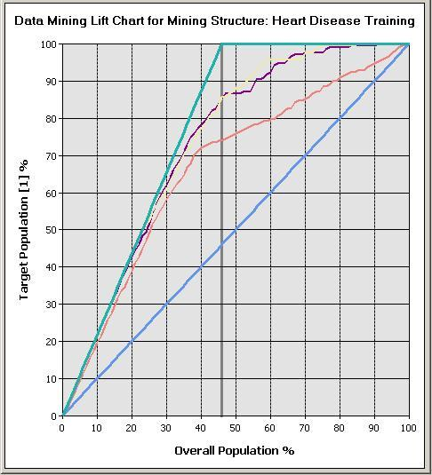
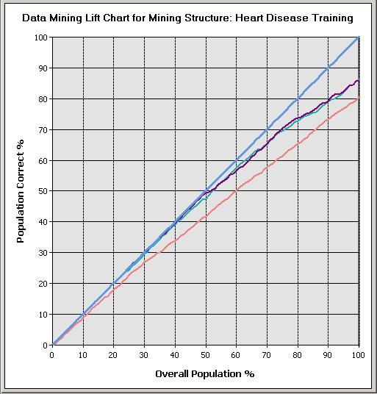

Fig1. Result of Life Chart With Predictable Value fig2. Result of Life Chart WithOut PredictableValue

The chart shows that if 50% of the population is processed, Neural Network gives the highest percentage of correct predictions (49.34%) followed by Naïve Bayes (47.58%) and Decision Trees (41.85%). If the entire population is processed, Naïve Bayes model appears to perform better than the other two as it gives the highest
number of correct predictions (86.12%) followed by Neural Network (85.68%) and Decision Trees (80.4%).

Processing less than 50% of the population causes the Lift lines for Neural Network and Naïve Bayes to be always higher than that for Decision Trees, indicating that Neural Network and Naïve Bayes are better at making high percentage of correct predictions than Decision Trees. Along the X-axis the Lift lines for Neural Network and Naïve Bayes overlap, indicating that both models are equally good for predicting correctly. When more than 50% of population is processed, Neural Network and Naïve Bayes appear to perform better as they give high percentage of correct predictions than Decision Trees. This is because the Lift line for Decision Trees is always below that of Neural Network and Naïve Bayes. For some population range, Neural Network appears to fare better than Naives Bayes and vice-versa.

Classification Matrix. Classification Matrix displays the frequency of correct and incorrect predictions. It compares the actual values in the test dataset with the predicted values in the trained model. In this example, the test dataset contained 208 patients with heart disease and 246 patients without heart disease. Figure 4 shows the results of the Classification Matrix for all the three models. The rows represent predicted values while the columns represent actual values (1 for patients with heart disease,‘0’ for patients with no heart disease). The left-most columns show values predicted by the models. The diagonal values show correct predictions.
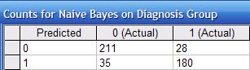
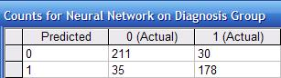

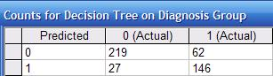

Fig3. Classification of Matrix

Figure 5 summarizes the results of all three models. Naïve-Bayes appears to be most effective as it has the highest percentage of correct predictions (86.53%) for patients with heart disease, followed by Neural Network (with a difference of less than 1%) and Decision Trees. Decision Trees, however, appears to be most effective for predicting patients with no heart disease (89%) compared to the other two models.

2.5.4. Evaluation of Mining Goals

Five mining goals were defined based on exploration of the heart disease dataset and objectives of this research. They were evaluated against the trained models. Results show that all three models had achieved the stated goals, suggesting that they could be used to provide decision support to doctors for diagnosing patients and discovering medical factors associated with heart disease. The goals are as follows:

Goal 1:

Given patients’ medical profiles, predict those who are likely to be diagnosed with heart disease. All three models were able to answer this question using singleton query and batch or prediction join query. Both queries could predict on single input cases and multiple input cases respectively. IHDPS supports
prediction using “what if” scenarios. Users enter values of medical attributes to diagnose patients with heart disease. For example, entering values Age = 70, CA = 2, Chest Pain Type = 4, Sex = M, Slope = 2 and Thal = 3 into the models, would produce the output in Figure 6. All three models showed that this patient has a heart disease. Naïve Bayes gives the highest probability (95%) with 432 supporting cases, followed closely by Decision Tree (94.93%) with 106 supporting cases and Neural Network (93.54%) with 298 supporting cases. As these values Are high, doctors could recommend that the patient should undergo further heart examination. Thus performing “what if” scenarios can help prevent a potential heart attack.

Goal 2:

Identify the significant influences and relationships in the medical inputs associated with the predictable state – heart disease. The Dependency viewer in Decision Trees and Naïve Bayes models shows the results from the most significant to the least significant (weakest) medical predictors. The viewer is especially useful when there are many predictable attributes. Figures 7 and 8 show that in both models, the most significant factor influencing heart disease is “Chest Pain Type”. Other significant factors include Thal, CA and Exang. Decision Trees model shows ‘Trest Blood Pressure” as the weakest factor while Naïve Bayes model shows ‘Fasting Blood Sugar’ as the weakest factor. Naïve Bayes appears to fare better than Decision Trees as it shows the significance of all input attributes. Doctors can use this information to further analyze the strengths and weaknesses of the medical attributes associated with heart disease.

Goal 3:

Identify the impact and relationship between the medical attributes in relation to the predictable state – heart disease. Identifying the impact and relationship between the medical attributes in relation to heart disease is only found in Decision Trees viewer (Figure 9). It gives a high probability (99.61%) that patients with heart disease are found in the relationship between the attributes (nodes): “Chest Pain Type = 4 and CA = 0 and Exang = 0 and Trest Blood Pressure >= 146.362 and < 158.036.” Doctors can use this information to perform medical screening on these four attributes instead of on all attributes on patients who are likely to be diagnosed with heart disease. This will reduce medical expenses, administrative costs, and diagnosis time. Information on least impact (5.88%) is found in the relationship between the attributes: “Chest Pain Type not = 4 and Sex = F”. Also given is the relationship between attributes for patients with no heart disease. Results show that the relationship between the attributes: “Chest Pain Type not = 4 and Sex = F” has the highest impact (92.58%). The least impact (0.2%) is found in the attributes: “Chest Pain Type = 4 and CA = 0 and Exang = 0 and Trest Blood Pressure >= 146.362 and < 158.036”. Additional information such as identifying patients’ medical profiles based selected nodes can also be obtained by using the drill through function. Doctors can use the Decision Tree viewer to perform

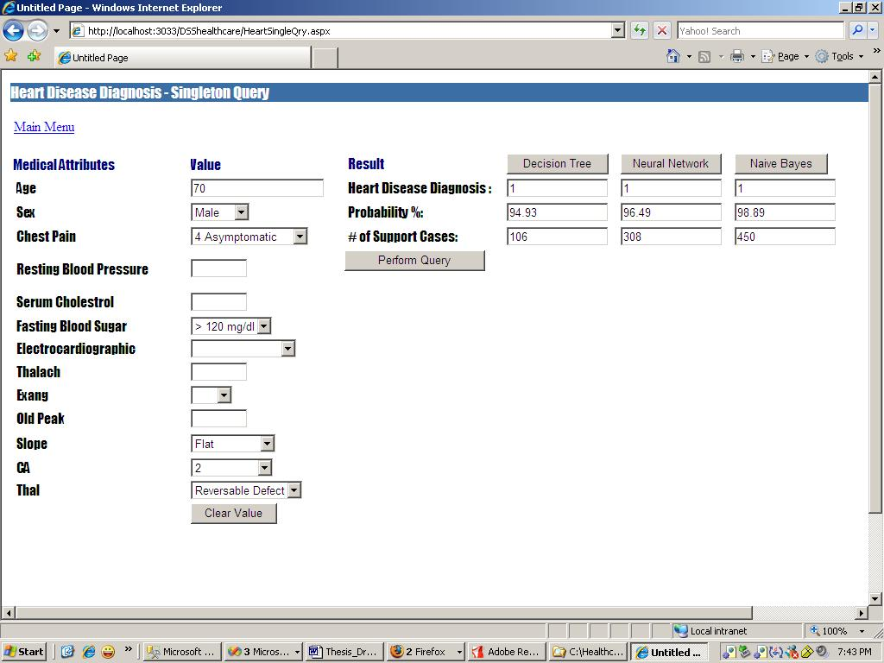

Fig4. Output for singleton query module

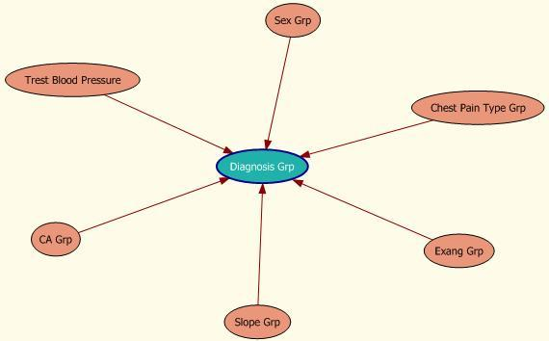
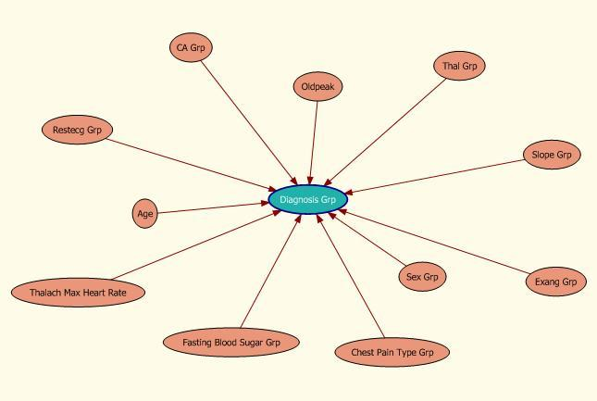

Fig5.Decision Trees dependency network fig6.Dependency network for naïve bayes

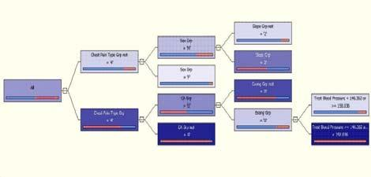

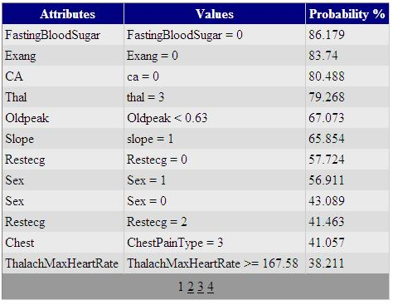

Figure 8. Naïve Bayes Attribute Characteristics Viewer in descending order for patients with heart disease

Goal 4: Identify characteristics of patients with heart disease. Only Naïve Bayes model identifies the characteristics of patients with heart disease. It shows the probability of each input attribute for the predictable state. Figure 10 shows that 80% of the heart disease patients are males (Sex = 1) of which 43% are between ages 56 and 63. Other significant characteristics are: high probability in fasting blood sugar with less than 120 mg/dl reading, chest pain type is asymptomatic, slope of peak exercise is flat, etc. Figure 11 shows the characteristics of patients with no heart disease with high probability in fasting blood sugar with less than 120 mg/dl reading, no exercise induced, number of major vessels is zero, etc. These results can be further analyzed.

Figure 9. Naïve Bayes Attribute Characteristic Viewer in
descending order for patients with no heart disease

Goal 5:
Determine the attribute values that differentiate nodes favoring and disfavoring the predictable states: (1) patients with heart disease (2) patients with no heart disease. This query can be answered by analyzing the results of attribute discrimination viewer of Naïve Bayes and Neural Network models. The viewer provides information on the impact of all attribute values that relate to the predictable state.Naïve Bayes model (Figure 12) shows the most important attribute favoring patients with heart disease: “Chest Pain Type = 4” with 158 cases and 56 patients with no heart disease. The input attributes “Thal = 7” with 123 (75.00%) patients, “Exang = 1” with 112 (73.68%) patients,” Slope =2” with 138 (66.34%) patients, etc. also favor predictable state. In contrast, the attributes “Thal = 3” with 195 (73.86%) patients, “CA = 0” with 198 (73.06%) patients, “Exang = 0” with 206 (67.98%), etc. favor predictable state for patients with no heart disease.
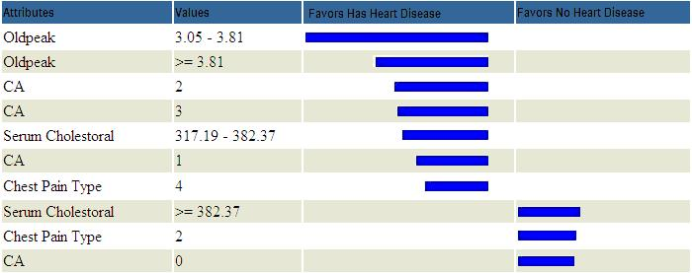

Figure 10. A Tornado Chart for Attribute Discrimination
Viewer in descending order for Naïve Bayes

Neural Network model (Figure 13) shows that the most important attribute value that favors patients with heart disease is “Old peak = 3.05 – 3.81” (98%). Other attributes that favor heart disease include “Old peak >=3.81”, “CA=2”, “CA=3”, etc. Attributes like “Serum Cholesterol >= 382.37”, “Chest Pain Type = 2”, “CA =0”, etc. also favor the predictable state for patients with no heart disease.
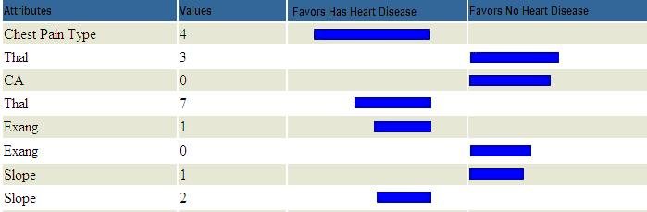

Figure 11. Attribute Discrimination Viewer in descending
order for Neural Network

2.6. Benefits and limitations

IHDPS can serve a training tool to train nurses and medical students to diagnose patients with heart disease. It can also provide decision support to assist doctors to make better clinical decisions or at least provide a “second opinion.” The current version of IHDPS is based on the 15 attributes listed in Figure 1. This list may need to be expanded to provide a more comprehensive diagnosis system. Another limitation is that it only uses categorical data. For some diagnosis, the use of continuous data may be necessary. Another limitation is that it only uses three
data mining techniques. Additional data mining techniques can be incorporated to provide better diagnosis. The size of the dataset used in this research is still quite small. A large dataset would definitely give better results. It is also necessary to test the system extensively with input from doctors, especially cardiologists, before it can be deployed in hospitals. [Access to the system is currently restricted to stakeholders.]

EXPLANATION OF THE DATAMINING:
INTRODUCTION

Information technology development over the last years grows rapidly and alters from single use centralized systems to distributed, multi-purpose systems. In such systems a useful tool for processing information and analyzing feature relationships is needed. Data mining (DM) technique has become an established method for improving statistical tools to predict future trends [3, 8]. There are a huge variety of learning methods and algorithms for rule extraction and prediction. Data mining (or knowledge discovery) is the process of analyzing data from different perspectives and summarizing it into useful information.

The aim is to achieve fast and simple learning models that result in small rule bases, which can be interpreted easily. In this particular study different data models are explored and evaluated by the test accuracy. For training the model non-parametric density estimation is used for improving the initial accuracy. First the unsupervised learning is conducted, and then a heuristic from experts is applied for specific rule generation. In the last section visual results from the experiments are presented and discussed.

PROBLEM STATEMENT

Detecting a disease from several factors or symptoms is a many-layered problem
that also may lead to false assumptions with unpredictable effects. Therefore, the attempt of using the knowledge and experience of many specialists collected in databases to support the diagnosis process is needed. The goal is to obtain simple intuitive models for interpretation and prediction. The advantage of combining such simple learning density functions and feature selection mechanism is that the resulting relational model is easy to understand and interpret [2]. Preliminary testing shows that knowledge extracted from heart diseases data can be efficiently used for classification of diagnosis.

If we make the rules more general, a greater number of the cases can be matched by one or more of the rules. To minimize their number some of the features are removed. The specific rule generation is based on pruned decision tree, where the most expressive attribute is increasingly weighted. The determination of the number of clusters is a central problem in data analysis.

In the conducted experiments the collected data records are preprocessed (scaled,
Cleaned) and classified. Each measurement is presented as a pixel in multidimensional space and data points are mapped by means of a Gaussian kernel to a high dimensional feature space, where the minimal enclosing sphere can be calculated. When mapped back to data space this sphere can be separated into several components, each enclosing a cluster of points. Separating the classes with a large margin minimizes the bound on the expected generalization error. In the case of non-separable classes, it minimizes the number of misclassifications whilst maximizing the margin with respect to the correctly classified examples. Unlike other algorithms, it makes no assumptions about the International Conference on Computer Systems and Technologies - CompSysTech’ 2006 relationships between a set of features (attributes) in a feature space. This allows us to identify and determine the most relevant features used in a model and the model's feature dependencies. As a result, non-linear modelling is done very accurately and classifiers are automatically generated. ML tuning methodology does not make any assumptions about correlation between features, as opposed to techniques that assume statistical independence.

USEFULNESS OF THE MODEL

If the goal is not just to represent the data set but also to make inferences about its
structure, it is essential to analyze whether the data set exhibits a clustering tendency, as sated in [6]. The results of the cluster analysis need to be validated. A potential problem is that the choice of the number of clusters may be critical. Good initialisation of the cluster centroids may also be crucial; some clusters may even be left empty if their centroids lie initially far from the distribution of data. The Bayesian rule is the optimal classification rule [7] but only if the underlying distribution of the data is known.

We have included into our DM analysis frequently used algorithms of estimating
parameters of non-supervised classifiers as well as methods of empirical segmentation and heuristic rule extraction [1]. One of the most important data mining tools is visualization of the available information, especially of multidimensional data. The visualization of several attributes in one computer screen is implemented for the visual heuristic analysis of correspondence between estimated parameters class value. Here we use standard methods of 2d and 3d graphics embedded in WEKA shell [8]. The visual class relations for the first 4 attributes of the heart example dateset are shown on fig.1
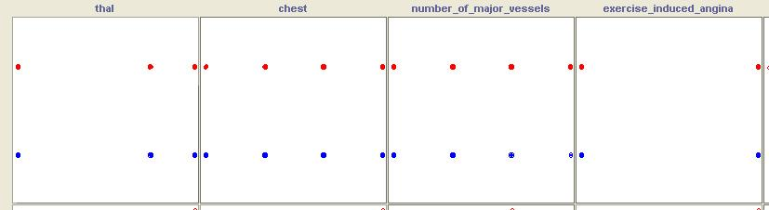

Figure 1. Representation of„thal“, „chest“, „n_major_vessel“ and „ex_angina“ attributes in relation to Class (on Y axis) for the Heart dataset. Standard methods used in data mining are principal component analysis and Kohonen' self organizing maps (SOM) [4, 5]. However, the component analysis is a linear projection method not always well representing the structure of multidimensional data.

SOM is not suitable to visualize large sets of multidimensional data. Parametric techniques rely on knowledge of the probability density function of each class. On the contrary, non-parametric classification does not need the probability density
function and is based on the geometrical arrangement of the points in the input space. We apply a non-parametric technique, k-nearest neighbors to verify the discriminability of the different feature spaces.

Since non-parametric techniques have high computational cost, we make use from some expert’s assumptions that lead to dimensionality reduction. The estimation of the local probability density at each point in the feature space is first calculated and then a minimal risk-based optimization is conducted. The density estimate group contains: k-nearest neighbour; radial basis functions; Naive Bayes; Polytrees; SOM; LVQ; and the kernel density method. After the optimal model is selected, the test set is run and compared. The accuracy and precision are calculated and results are given in table1.

When using non-linear RBF model the correctly classified cases are 84.07%. This
outperformed the linear model, which did with an average accuracy of 75.4%. Compared against a Naïve Bayes, which achieved an average test accuracy of 78.6%, the kernel

Model | Test accuracy | Precision | T Positive Rate | Expert refinement
PART C4.5 | 75.738 % | 0.757 | 0.767 | 81.28 %
Naïve Bayes | 78.563 % | 0.795 | 0.800 | 84.24 %
Decision Table | 82.4348 % | 0.841 | 0.877 | 84.33 %
Neural nets | 82.773 % | 0.840 | 0.840 | N/A
Voted perception | 83.704 % | 0.844 | 0.793 | 83.74 %
SMO | 84.074 % | 0.845 | 0.873 | N/A
RBF Gaussian | 84.074 % | 0.845 | 0.873 | 85.31 %
Repeated Inc Pruning | 84.3576 % | 0.823 | 0.813 | 81.33 %
Kernel density | 84.4444 % | 0.880 | 0.800 | 87.67 %

density algorithm is the optimal non-linear model selected on the training set (with Density (precision of 0.88) achieved test accuracy of 84.44% which is the best result in the experiments. This is at least partially due to the use of 10-fold cross validation and to a model that generalizes well. The auto-training approach for selecting the optimal model requires finding the optimal combination of all parameters.

The decision-tree method like the nearest-neighbors method, exploits clustering
regularities for the purposes of classifying new examples. It constructs a decision-tree representation of the data and provides a hierarchical description of the statistical structure of the data. It shows implicitly which variables are more significant with respect to classification decisions. Most clustering methods based on heuristic are approximate estimation for particular probability models.

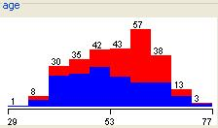
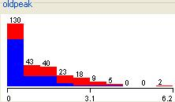

Figure 12. The most relevant attribute distribution („thal“) is used for diagnosis prediction.

LEARNING MODELS

The basis of the model consists in viewing a numeric value, i.e. measure as being
dependent on a set of attributes, dimensions. Each classifier uses its own representation of the input pattern and operates in different measurement systems. A well-known approach is the weighted sum, where the weights are determined through a Bayesian decision rule. Regression is the oldest and most well known statistical technique (for continuous quantitative) that the DM community utilizes. For categorical data (like color, name or gender) DM technique is successfully used [9]. This technique is much easier to interpret by human. If the resulting attribute distribution is broad and flat we know that the partial observation does not contain sufficient relevant information to predict this attribute. If the distribution has a sharp single peak we can predict the attribute value with confidence.

International Conference on Computer Systems and Technologies - CompSysTech’ 2006
The distribution’s visualization for the first 4 important attributes is given on figure 2. The most relevant attribute used for diagnostic prediction is „thal“, obtained from experts. The effects of noise and deviation from the normal distribution in the data pose natural limitations to both methods’ prediction capabilities. Most clustering methods based on heuristic are approximate estimation for particular probability models. The goal of the described data mining techniques is to aid the development of a reliable model.

SPECIFIC RULE EXTRACTION

The default rule relies only on knowledge of the prior probabilities, and clearly the
decision rule that has the greatest chance of success is to allocate every new observation to the most frequent class. However, if some classification errors are more serious than others we adopt the minimum risk (least expected cost) rule and the class C_{k}is that with the least expected cost.

A rule-set set is formed from C4.5 decision tree algorithm by identifying each root-to- leaf path with a rule. Each rule is simplified by successively dropping conditions (attribute-tests). The difference lies in the sophistication of criteria used for retracting a trial generalisation when it is found to result in inclusion of cases not belonging to the rule’s decision class.

In the noise-free taxonomy problem a single „false positive“ was taken to bar dropping the given condition. After that we reveal which rule explains the presence of disease most accurately. The final predictions are based on the most accurate rule.

All the records where the predicted value fits the actual value are explained by the specific generated rules. The proportion between the success rate of the positive and negative predictions is the result of the proportion between the price of a miss and the price of a false alarm.

The specific rule is: If (thal>=4.5) and Chest (>=4) => class is ”Yes”

Class Distributions thal<=4.5 “NO” “YES”
0.7828947 0.217105

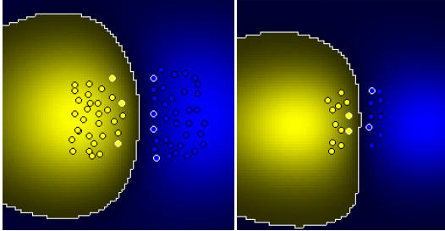
If thal>=4.5 “NO” “YES”
0.2627118 0.737288

Figure 3: The frontiers designed with a Gaussian kernel (right picture) is based only on the selected support vectors instead of a real class distribution (on the left picture)

As illustrated in figure 3 on a very simple problem, the frontiers designed with a Gaussian kernel confirm that it tends to draw unreliable separation frontiers in the input data space (based only on the selected support vectors instead of a real class distribution). In our approach we assume that we have to estimate the n imensional density function f_{x}(p) of an unknown distribution. Then, the probability, P that a vector x will fall in a region R is:

P ∫_{R} )
f ( xdx(1)

Suppose that n observations are drawn independently according to f_{x} Then we can
Approach P by k/n where k is the number of these n observations falling in R.

EXPERIMENTAL RESULTS

In diagnosis applications the outcome may be the prediction of disease vs. normal or in prognosis applications. The input features may include clinical variables from medical examinations, laboratory test results, or other measurements. The objectives of feature selection are: reducing the cost of production of the predictor, increasing its speed, improving its prediction performance and/or providing an interpretable model.

The purpose of this experimental dataset is to predict the presence or absence of heart disease given the results of various medical tests carried out on a patient. This dataset contains 13 attributes, which have been extracted from a larger set of 75. There are two classes: presence and absence (of heart disease). RBF Gaussian model and SMO performed well on the heart dataset. This may reflect the careful selection of attributes by the doctors. After expert refinement Kernel density performed the best. The achieved result from 87.67 % gives good perspectives especially when lognormal or skewed distributions are estimated. The leading correlation coefficient (that gives a measure of predictability) is 0.7384 and as such is not very high. Therefore, the discriminating power of the linear discriminant is only moderate.

Despite being one of the fastest methods for learning support vector machines, SMO(sequential minimal optimization) is often slow to converge to a solution—particularly when the data is not linearly separable in the space spanned by the non-linear mapping.The optimal model is then picked based on the highest accuracy value and then the whole training dataset is retrained with the optimization parameters of the selected model to produce a new optimized model. The user can create a model by choosing the type of model, for example linear or non-linear, as well as the parameters for that type of model. It is clear that if we choose the model (and hence the class) to maximise the accuracy value, then we will choose the correct class each time. We note that an optimal diagnosis assumes all costs to be expressed on a single numerical scale (need not correspond toeconomic cost). Non-parametric density estimation usually requires a large amount of training data to provide a good estimate of the true distribution of a data set.

Because of this property and the small size of the heart data set, the high testing accuracy we achieved was unexpected. The most important factor is how well the training set represents the actual distribution of the data. Due to the accuracy of our classifiers, it appears that the patients with the higher „thal“ attribute are highly related to the positive class. The density estimates could be improved by finding more accurate estimates of the a priori probabilities by sampling the patient population. Traditionally model selection and parameterization is difficult for new data sets, even for experienced users. We generated models by: manually specifying which type of model and parameters to use, performing a Search across various model types and parameters, and by doing an DM analysis.

PROJECT MODULES:

- Analysing the algorithms
- Naïve Bayes
- Decision Tree
- Neural Networks
- Login Module
- Implementing Business Intelligence
- Final Output with Using DMX

- Analyzing the algorithms
In this module we are analyzing the possible algorithms such as naïve bayes, Decision Trees, Neural Networks. Within the three algorithms we have choose the best one for our project.
The attribute “Diagnosis” was identified as the predictable attribute with value “1” for patients with heart disease and value “0” for patients with no heart disease. The attribute “PatientID” was used as the key; the rest are input attributes. It is assumed that problems such as missing data, inconsistent data, and duplicate data have all been resolved.
The effectiveness of models was tested using two methods: Lift Chart and Classification Matrix. The purpose was to determine which model gave the highest percentage of correct predictions for diagnosing patients with a heart disease.
- Login Module: In this module the can login using their username, password. Also, in this module user has to give details to register as a member in this website
- Implementing Business Intelligence:

In this module the user implements the business intelligence algorithm to generate the reports using three algorithms
- Final Output with Using DMX

Data Mining Extension (DMX), a SQL-style query language for data mining, is used for building and accessing the models’ contents. Tabular and graphical visualizations are incorporated to enhance analysis and interpretation of results. Finally, we show the output results using DMX query.

5.1 EXISTING SYSTEM
- Clinical decisions are often made based on doctors’ intuition and experience rather than on the knowledge rich data hidden in the database.
- Medical Misdiagnoses are a serious risk to our healthcare profession. If they continue, then people will fear going to the hospital for treatment. We can put an end to medical misdiagnosis by informing the public and filing claims and suits against the medical practitioners at fault.
- There are many ways that a medical misdiagnosis can present itself. Whether a doctor is at fault, or hospital staff, a misdiagnosis of a serious illness can have very extreme and harmful effects.
- This practice leads to unwanted biases, errors and excessive medical costs which affects the quality of service provided to patients.
- The National Patient Safety Foundation cites that 42% of medical patients feel they have had experienced a medical error or missed diagnosis. Patient safety is sometimes negligently given the back seat for other concerns, such as the cost of medical tests, drugs, and operations

DISADVANTAGE
- There are many ways that a medical misdiagnosis can present itself. Whether a doctor is at fault, or hospital staff, a misdiagnosis of a serious illness can have very extreme and harmful effects.
- This practice leads to unwanted biases, errors and excessive medical costs which affects the quality of service provided to patients.
- The National Patient Safety Foundation cites that 42% of medical patients feel they have had experienced a medical error or missed diagnosis.
- Patient safety is sometimes negligently given the back seat for other concerns, such as the cost of medical tests, drugs, and operations.

5.2. PROPOSED SYSTEM :

This practice leads to unwanted biases, errors and excessive medical costs which affects the quality of service provided to patients.

Thus, we proposed that integration of clinical decision support with computer-based patient records could reduce medical errors, enhance patient safety, decrease unwanted practice variation, and improve patient outcome.
This suggestion is promising as data modeling and analysis tools, e.g., data mining, have the potential to generate a knowledge-rich environment which can help to significantly improve the quality of clinical decisions.
The main objective of this research is to develop a prototype Intelligent Heart Disease Prediction System (IHDPS) using three data mining modeling techniques, namely, Decision Trees, Naïve Bayes and Neural Network.
So its providing effective treatments, it also helps to reduce treatment costs. To enhance visualization and ease of interpretation.
The main objective of this research is to develop a Intelligent Heart Disease Prediction System using three data mining modeling technique, namely, Naïve Bayes. It is implemented as web based questionnaire application Based on the user answers, it can discover and extract hidden knowledge (patterns and relationships) associated with heart disease from a historical heart disease database. It can answer complex queries for diagnosing heart disease and thus assist healthcare practitioners to make intelligent clinical decisions which traditional decision support systems cannot. By providing effective treatments, it also helps to reduce treatment costs.

ADVANTAGE
- This suggestion is promising as data modeling and analysis tools, e.g., data mining, have the potential to generate a knowledge-rich environment which can help to significantly improve the quality of clinical decisions.
- The main objective of this research is to develop a prototype Intelligent Heart Disease Prediction System (IHDPS) using three data mining modeling techniques, namely, Decision Trees, Naïve Bayes and Neural Network.
- So, it providing effective treatments, it also helps to reduce treatment costs. To enhance visualization and ease of interpretation,

5.3. Functional Environment

FEASIBILITY CONSIDERATION
Three key considerations are involved in feasibility analysis: economic, technical and behavioral. Let’s briefly review each consideration and its relation to systems effort.

TECHNICAL FEASIBILITY
Technical feasibility centers on the existing computer system (hardware, software, etc,) and to what extent it can support the proposed addition. For example, if the current computer is operating at 80 percent capacity an arbitrary ceiling. then running another application could overload the system or require additional hardware. This involves financial considerations to accommodate technical enhancements.

ECONOMICAL AND SOCIAL FEASIBILITY
Economic analysis is the most frequently used method for evaluating the effectiveness of a candidate system. More commonly known as cost/benefit analysis, the procedure is to be determining the benefits and savings that are expected from a candidate system and compare them with costs.
Otherwise, further justification or alterations in the proposed system will have to be made if it is to have a chance of being approved. This is ongoing effort that improves accuracy, at each phase of the system life.

BEHAVIORAL FEASIBILITY
People are inherently resistant to change and computers have been known to facilitate change. An estimate should be made of how strong a reaction the user staff is likely to have towards the development of a computerized system. It is the common knowledge that computer installations have something to do with turnover, transfer, retraining and changes in employee job status. Therefore, it is understandable.

STEPS IN FEASIBILITY STUDY

- Form a project team and appoint a project leader.
- Prepare system flowcharts.
- Enumerate potential candidate system.
- Describe and identify characteristics of candidate systems.
- Form a project team and appointing a project leader.
- Prepare system flowcharts.
- Enumerate potential candidate system.
- Describe and identify characteristics of candidate systems.
- Determine and evaluate performance and cost effectiveness of each candidate system.
- Weight system performance and cost data.
- Select the best candidate system.
- Prepare and report final project directive to management.
- Form a project team and appointing a project leader.
- Prepare system flowcharts.
- Enumerate potential candidate system.
- Describe and identity characteristics of candidate systems.
- Determine and evaluate performance and cost effectiveness.
- Weight system performance and cost data.
- Select the best candidate system.
- Prepare and report the final project directive to management.

5.4 SYSTEM REQUIREMENT
Hardware Environment
Server Side
Processor : Intel
HDD : Minimum 20 MB Disk Space
RAM : Minimum 64 MB
Database : SQL Server 2000

Client Side
Processor : AMD, Intel
HDD : Minimum 30MB free disk space
RAM : Minimum 32MB
OS : Windows 98 or above

Software Environment
Operating System : Windows XP
Front-End : ASP.NET with C#
Back-End : SQL Server 7.0
Web Server : IIS

5.5. ABOUT MICROSOFT .NET FRAMEWORK

Overview of the .NET Framework
The Microsoft .NET Framework is an integrated and managed environment for the development and execution of the code. It manages all aspects of a program’s execution. It allocates memory for the storage of data and instructions, grants or denies the appropriate permissions to your application, initiates and manages application execution, and manages the reallocation of memory from resources that are no longer needed.

The .NET Framework consists of two main components:
- The common language runtime.
- The .NET Framework class library.
The common language runtime can be thought of as the environment that manages code execution. It provides core services, such as code compilation, memory allocation, thread management, and garbage collection. Through the common type system (CTS), it enforces strict type-safety and ensures that code is executed in a safe environment by also enforcing code access security.

The .NET Framework class library provides a collection of useful and reusable types that are designed to integrate with the common language runtime. The types provided by the .NET Framework are object-oriented and fully extensible, and they allow the user to seamlessly integrate applications with the .NET Framework.

Languages and the .NET Framework
The .NET Framework is designed for cross-language compatibility, which means, simply, that .NET components can interact with each other no matter what supported language they were written in originally. So, an application written in Microsoft Visual Basic .NET might reference a dynamic-link library (DLL) file written in Microsoft Visual C#, which in turn might access a resource written in managed Microsoft Visual C++ or any other .NET language. This language interoperability extends to full object-oriented inheritance. A Visual Basic .NET class might be derived from a C# class, for example, or vice versa.
This level of cross-language compatibility is possible because of the common language runtime. When a .NET application is compiled, it is converted from the language in which it was written (Visual Basic .NET, C#, or any other .NET-compliant language) to Microsoft Intermediate Language (MSIL or IL). MSIL is a low-level language that the common language runtime can read and understand. Because all .NET executables and DLLs exist as MSIL, they can freely interoperate. The Common Language Specification (CLS) defines the minimum standards to which .NET language compilers must conform. Thus, the CLS ensures that any source code successfully compiled by a .NET compiler can interoperate with the .NET Framework.

The Structure of a .NET Application
The primary unit of a .NET application is the assembly. An assembly is a self-describing collection of code, resources, and metadata. The assembly manifest contains information about what is contained within the assembly. The assembly manifest provides:
- Identity information, such as the assembly’s name and version number.
- A list of all types exposed by the assembly.
- A list of other assemblies required by the assembly.
- A list of code access security instructions, including permissions required by the assembly and permissions to be denied the assembly.
Each assembly has one and only one assembly manifest, and it contains all the description information for the assembly. An assembly contains one or more modules. A module contains the code that makes up the application or library, and it contains metadata that describes that code. When a project is compiled into an assembly, the code is converted from high-level code to IL

Each module also contains a number of types. Types are templates that describe a set of data encapsulation and functionality. There are two kinds of types:

Reference types (classes).
Value types (structures).

A type can contain fields, properties, and methods, each of which should be related to a common functionality. A field represents storage of a particular type of data. Properties are similar to fields, but properties usually provide some kind of validation when data is set or retrieved. Methods represent behaviour, such as actions taken on data stored within the class or changes to the user interface.

The .NET Base Class Library
The .NET base class library is a collection of object-oriented types and interfaces that provide object models and services for many of the complex programming tasks you will face.

Most of the types presented by the .NET base class library are fully extensible, allowing the user to build types that incorporate with their own functionality into the managed code.

The .NET Framework base class library contains the base classes that provide many of the services and objects needed when writing applications. The class library is organized into namespaces. A namespace is a logical grouping of types that perform related functions.

Namespaces are logical groupings of related classes. The namespaces in the .NET base class library are organized hierarchically. The root of the .NET Framework is the System namespace. Other namespaces can be accessed with the period operator.

A typical namespace construction appears as follows:

System
System.Data
System.Data.OLEDBClient

The first example refers to the System namespace. The second refers to the System.Data namespace. The third example refers to the System.Data.SQLClient namespace.

The namespace names are self-descriptive by design. Straightforward names make the .NET Framework easy to use and allows the user to get rapidly familiarize with its contents.

Using .NET Framework Types in an Application
When beginning to write an application, the user automatically begin with a reference to the .NET Framework base class library. It is referenced so that the application is aware of the base class library and is able to create instances of the types represented by it.

Value Types
In Visual Basic .NET, the Dim statement is used to create a variable that represents a value type.

Reference Types
Creating an instance of a type is a two-step process. The first step is to declare the variable as that type, which allocates the appropriate amount of memory for that variable but does not actually create the object.

Nested Types

Types can contain other types. Types within types are called nested types. Using classes as an example, a nested class usually represents an object that the parent class might need to create and manipulate, but which an external object would never need to create independently.

Instantiating User-Defined Types

A user can declare and instantiate a user-defined type the same way that he declares and instantiate a .NET Framework type. For both value types (structures) and reference types (classes), he needs to declare the variable as a variable of that type and then create an instance of it with the New (new) keyword.

The Imports Statement

To access a type in the .NET Framework base class library, the user has to use the full name of the type, including every namespace to which it belonged. For example: System.Windows.Forms.Form. This is called the fully-qualified name, meaning it refers both to the class and to .the namespace in which it can be found.

The development environment can be made “aware” of various namespaces by using the Imports. This technique allows the user to refer to a type using only its generic name and to omit the qualifying namespaces. Thus, you could refer to System.Windows.Forms.Form as simply Form.

Referencing External Libraries

There are some class libraries which are not contained by the .NET Framework, such as libraries developed by third-party vendors or libraries you developed. To access these external libraries, the user must create a reference.

Classes and Structures
Classes are templates for objects. They describe the kind and amount of data that an object will contain, but they do not represent any particular instance of an object.

Members

Classes describe the properties and behaviours of the objects they represent through members. Members are methods, fields, properties, and events that belong to a particular class. Fields and properties represent the data about an object.

A method represents something the object can do, such as move forward or turn on headlights. An event represents something interesting that happens to the object, such as overheating or crashing.

Garbage Collection

Because garbage collection does not occur in any specific order, it is impossible to determine when a class’s destructor will be called.

The .NET Framework provides automatic memory reclamation through the garbage collector. The garbage collector is a low-priority thread that always runs in the background of the application. When memory is scarce, the priority of the garbage collector is elevated until sufficient resources are reclaimed.

Because the user cannot be certain when an object will be garbage collected, he should not rely on code in finalizers or destructors being run within any given time frame. If he has resources that need to be reclaimed as quickly as possible, provide a Dispose() method that gets called explicitly.
- The garbage collector continuously traces the reference tree and disposes of objects containing circular references to one another in addition to disposing of unreferenced objects.
ADO.NET
ActiveX Data Objects for the .NET framework (ADO.NET) is a set of classes that expose data access services to the .NET programmer. ADO.NET provides a rich set of components for creating distributed, data sharing applications.

It is an integral part of .NET framework, providing access to relational data, XML and application data. ADO.NET supports a variety of development needs, including the creation of front end database, clients and middle tier business objects used by applications, tools, languages or Internet browsers.

ADO.NET provides consistent access to data source such as Microsoft Access, as well as data sources expose via OLEDB and XML. Data sharing consumer application can use ADO.NET to connect to these data sources and retrieve, manipulate and update data.

ABOUT MICROSOFT ASP .NET

MICROSOFT RELEASED the .NET Framework 1.0 Technology preview in July 2000, it was immediately clear the Web development was going to change. The company’s then current technology, Active Server Page 3.0(ASP), was powerful and flexible, and it made the creation of dynamic Web sites easy. ASP spawned a whole series of books, articles, Web sites, and components, all to make the development process even easier. What ASP didn’t have, however, was an application framework; it was never an enterprise development tool. Everything you did in ASP was code oriented you just couldn’t get away without writing code. ASP.Net was designed to counter this problem.One of its key design goals was to make programming easier and quicker by reducing the amount of code you have to create.
Enter the declarative programming model, a rich server control hierarchy with events, a large class library, and support for large development tools from the humble notepad to the high-end Visual Studio.NET. All in all ASP.NET was a huge leap forward. Much time you have to do it in. There is an almost never-ending supply of features you can add, but at some stage you have to ship the product. You cannot doubt that ASP.NET 1.0 shipped with an impressive array of features, but the ASP.NET team members are ambitious, and they not only had plans of their own but also listened to their users. ASP.NET 2.0 , code-named “Whidbey”, addresses the areas that both the development team and users wanted to improve. The aims of the new version are listed below.

ASP.NET provides a programming model and infrastructure that offers the need services for programmers to develop Web-based applications. As ASP.NET is a part of the .NET Framework, the programmers can make use of the managed Common Language Runtime (CLR) environment, type safety, and inheritance etc to create Web-based applications.

You can develop your ASP>NET Web-based application in any .NET complaint languages such as Microsoft Visual Basic, Visual C#, and Jscript.NET.

ASP.NET offers a novel programming model and infrastructure that facilitates a powerful new class of applications. Developers can effortlessly access the advantage of these technologies, which consist of a managed Common Language Runtime environment, type safety, inheritance, and so on. With the aid of Microsoft Visual Studio.

Web Forms:

Permits us to build powerful forms–based Web pages. When building these pages, we can use Web Forms controls to create common UI elements and program them for common tasks. These controls permit us to rapidly build up a Web Form.

Web services:

Enable the exchange of data in client-server scenarios, using standards like HTTP, SOAP(Simple Object Access Protocol) and XML messaging to move data across firewalls. XML provides meaning to data, and SOAP is the protocol that allows web services to communicate easily with one another. Web services are not tied to a particular component technology or object-calling convention. As a result, programs written in any language, using any component model, and running on any operating system can access Web services.

Why ASP.NET?

Since 1995, Microsoft has been constantly working to shift its focus form Windows-based platform to the Internet. As a result, Microsoft introduced ASP (Active Server Pages) in November 1996. ASP offered the efficiency of ISAPI applications along with a new level of simplicity that made it easy to understand and use. However, ASP script was an interpreted script and consisted unstructured code and was difficult to debug and maintain. As the web consists of many different technologies, software integration for Web development was complicated and required to understand many different technologies. Also, as applications grew bigger in size and became more complex, the number of lines of source code in ASP applications increased dramatically and was hard to maintain. Therefore, an architecture was needed that would allow development of Web applications in a structured and consistent way.

The .Net Framework was introduced with a vision to create globally distributed software with Internet functionality and interoperability. The .NET Framework consists of many class libraries, includes

About C#

C# (pronounced "C sharp") is a new language designed by Microsoft to combine the power of C/C++ and the productivity of Visual Basic. Initial language specifications also reveal obvious similarities to Java, including syntax, strong web integration and automatic memory management. C# is the key language for Microsoft's next generation of Windows services, the .NET platform. This new programming language is fast and modern and was designed to increase programmer productivity. C# enables programmers to quickly build a wide range of applications for the new Microsoft .NET platform. The .Net platform enables developers to build C# components to become Web services available across the Internet.

C# Data Types

static variables
Variable of instance
Array's elements
Parameters given by reference
Parameters given by value
Returned values
Local variables.

Constants in C#:

Constant type of data cannot be changed. To declare a constant the keyword const is used. An example for the constant declaration is: const double PI = 3.1415;

Values types in C#:

Value type stores real data. When the data are queried by different function a local copy of it these memory cells are created. It guarantees that changes made to our data in one function don't change them in some other function.

Common types in C#:

Object in C# language is universal; it means that all supported types are derived from it. It contains only a couple of methods: GetType() - returns a type of object, ToString() returns string equivalent of type that called.

Next type is class. It is declared in the same manner as structure type but it has more advanced features.

Interface is an abstract type. It is used only for declaring type with some abstract members. It means members without implementations. Please, have a look at piece of code with a declaration for a simple interface:

OOP & C#:

All the programming languages supporting Object oriented Programming will be supporting these three main concepts:

Encapsulation
Inheritance
Polymorphism

Encapsulation:

Encapsulation is process of keeping data and methods together inside objects. In this way developer must define some methods of object? interaction. In C#, encapsulation is realized through the classes. A Class can contain data structures and methods.

Inheritance:

Inheritance is the process of creation new classes from already existing classes. The inheritance feature allows us to reuse some parts of code. constructor also inherits base class constructor. We can inherit all the members that has access modifier higher than protected class.

Polymorphism:

Polymorphism is possibility to change behavior with objects depending of object’s data type. In C# polymorphism realizes through the using of keyword virtual and override.

The runtime keeps record of all the virtual function details in a table called VMT (Virtual Method Table) and then in runtime dynamically picks the correct version of the function to be used.

Namespaces:

A Namespace in Microsoft .Net is like containers of objects. They may contain unions, classes, structures, interfaces, enumerators and delegates. Main goal of using namespace in .Net is for creating a hierarchical organization of program. In this case a developer does not need to worry about the naming conflicts of classes, functions, variables etc., inside a project

In Microsoft .Net, every program is created with a default namespace. This default namespace is called as global namespace. But the program itself can declare any number of namespaces, each of them with a unique name. The advantage is that every namespace can contain any number of classes, functions, variables and also namespaces etc., whose names are unique only inside the namespace. The members with the same name can be created in some other namespace without any compiler complaints from Microsoft .Net. To declare namespace C# .Net has a reserved keyword namespace. If a new project is created in Visual Studio .NET it automatically adds some global namespaces. These namespaces can be different in different projects. But each of them should be placed under the base namespace System. The names space must be added and used through the using operator, if used in a different project.

Exceptions

Practically any program including c# .net can have some amount of errors. They can be broadly classified as compile-time errors and runtime errors. Compile-time errors are errors that can be found during compilation process of source code. Most of them are syntax errors. Runtime errors happen when program is running.

Exceptions in C# can be called using two methods:

Using the throw operator. It call the manage code anyway and process an exception. If using the operators goes awry, it can generate an exception.

C# language uses many types of exceptions, which are defined in special classes. All of them are inherited from base class named System.Exception. There are classes that process many kinds of exceptions: out of memory exception, stack overflow exception, null reference exception, index out of range exception, invalid cast exception, arithmetic exception etc. This c# tutorial deals with DivideByZero c# exception and custom classes in c# exceptions.

C# has defined some keywords for processing exceptions. The most important are try, catch and finally.

Interfaces

An Interface is a reference type and it contains only abstract members. Interface's members can be Events, Methods, Properties and Indexers. But the interface contains only declaration for its members. Any implementation must be placed in class that realizes them. The interface can't contain constants, data fields, constructors, destructors and static members.

6. Project Requirements

6.1. Functional Requirements

It deals with the logical description of the module involved in the process.

6.2. Performance Requirements

It describes speed, availability, response time, recovery time and integrity of various software functions.

Instant data access
High level security
Data validation
Dynamic updating

6.3. Interface Requirements

User interface describes the ease of interface design use without any confusion.

Suitable design
Automatic generation
User friendly components like text box, combo box, button.

6.4. Operational Requirements:

A software product is composed of code and documentation. Documentation consists of all information about the software except the code itself. The production of effective documentation is sometimes overlooked, but it is vital to the success of software Engineering.

6.5. Security Requirements

It deals with High level security maintenance of employee as well as management. The data must valid and integrity. In this system the management only accesses all the information about the system. The employee only access certain limited information and limited time span. The system also provides the security for access out side the organization by using https protocol.

6.6 Design Requirements

Free hand SQLData is directly extracted from the source (SQL server).It is called an independent top down approach.
The Corporate Monitoring is necessary the data should be needed and data’s are combined one form i.e., called top down approach. Reports make using the tools in Asp.net. The reports have many forms. They namely such as,

Standard controls
Stored Procedure Server

7. SYSTEM DESIGN

7.1. Interface Design

Database and web server act as interface Login, username, password and other role are stored and checked in Database.

Employee details are viewed use of database. All the information about the concern is viewed use of database.

7.2. Front End Design

The front end designed using ASP.Net Using c# Language and Standard controls, toolbox.

Microsoft .Net is a set of Microsoft Software technologies for connecting your world of information, people, systems, and devices. It enables an unprecedented level of software integration through the use of XML, Web services, small, discrete, building block application that connect to each other.

• JIT -> Just in time
• MSIL ->Microsoft Intermediate Language
• CLR ->Common Language Runtime
• BCL ->Base Class Library

Core Concepts

Web development platform.
New programming model.
Separate layout and business logic.
Use services provided by the .NET Framework.
Code is compiled the first time a page is requested
State management

7.3 BackEnd Design

Back end is mainly used to store the data and also retrieve the data.
SQL SERVER is one of the most powerful Server. It is used to maintaining the data.

8. SYSTEM TESTING

Software testing is an important element of software quality assurance and represents the ultimate review of specification, design and coding. The increasing visibility of s/w as a system element and the costs associated with an s/w failure are motivating forces for well planned through testing.

Testing Objectives

There are several rules that can serve objectives. They are

Testing is process of executing a program with the intent of finding an error.
A good test case is one that has a high probability of finding an undiscovered error.
A successful test is one that uncovers an undiscovered error.

8.1.1 UNIT TESTING

Unit Test comprises the set of tests performed by an individual programmer prior to integration of the unit into a large system It is illustrated as,

Code and Debugging→Unit Testing→Integration

A program unit is usually small enough that the programmer who developed it can test it in great detail and certainly this will be possible when the unit test integrated into an evolving software product.
There are 4 categories of test that a programmer will typically perform on a program unit.

a) Functional Test

Functional Test cases involve exercising the code with the nominal input value for which the expected results are known.

b) Performance Test

Performance Test determines the amount of execution time spend in various parts of unit, program throughput and response time and device utilization by the program unit.

c) Stress Test

Stress Tests are those designed to intentionally break the unit. A great deal can be learned about the strength and limitations of a program by examining the manner in which a program unit breaks.

d) Structure Test

Structure test are concentrated with exercising the internal logic of a program and traversing particular execution path. Program error can be classified as the missing path errors, computational error and domain error.

8.1.2 INTEGRATION TESTING

The first step in the testing is the top-down approach was the integration is carried from low-level module to the top.

In the bottom up approach the integration is carried out from the top-level module to the bottom.

The modules are generally tested using the bottom-up approach by introducing steps from the top-level function.

9. Implementation

Implementation is that stage in the project where the theoretical design is turned into a Work system. The most crucial stage in achieving a new successful system and in giving confidence on the new system and effectively. The user is first displayed with a front screen, which on clicking takes the user to the Login Screen. The Main setting form is the center of functioning. The user has to select the required operations or tables he wants to manipulate. The software constantly performs validations on the data entering the system and checks for any cracks in the network and corrects the necessary errors. The more complex the system being implemented, analysis and design effort required for implementation.

The implementation stage is, in its own right, a system project. It involves a careful planning, investigation of the current system and its constraints on implementation, training of the users in the changeover procedures and evaluation of change over methods.

The tasks involved in the implementation are:

Implementation planning.
Computer System testing.
Tool learning.
The different module learning and their properties.
The using of the different options provided for a particular user.

Normalization

One of the more complicated topics in the area of database management is the process of normalizing the tables in a relational database. These notes are intended to provide you with an overview of this topic, which I hope will be helpful to you after you have gained some familiarity with the ideas of, and techniques used in, normalization.

The underlying ideas in normalization are simple enough. Through normalization we want to design for our relational database a set of files that (1) contain all the data necessary for the purpose that the database is to serve, (2) have as little redundancy as possible, (3) accommodate multiple values for types of data that require then, (4) permit efficient updates of the data in the database, and (5) avoid the danger of losing data unknowingly

The primary reason for normalization database to at least the level of the 3rd Normal Form (the levels are explained below) is that normalization is normalization is a potent weapon the possible corruption of database stemming from what are called ”insert anomalies,” “deletion anomalies,” and “update anomalies”. These types of error can creep an into database that are insufficiently normalized.

The most important and widely used normal form is as follows:

First Normal Form(1NF)
Second Normal Form(2NF)
Third Normal Form(3NF)
Boyce-code Normal Form(BCNF)

First Normal Form

A table is said to be in INF when each cell of the table contains precisely one value. All the tables in the online application satisfy this condition hence, the tables are in INF.

Second Normal Form

A table is said to be in 2NF when it is in 1NF and every attribute in the row is functionally dependent upon the whole key, and not just part of the key. All the tables in this online application satisfy this condition hence, the tables are 2NF.

Third Normal Form

A table is said to be in 3NF when it is 2NF and every non-key attribute is functionally dependent only on the primary key. All the tables in this online application satisfy this condition hence, the tables are in 3NF.

Boyce –Code Normal Form

A table is in the Boyce-code Normal Form (BCNF) if and only if every determination is a candidate key. Database files are the key source of information into the system.

It is the process of information to the system and the system and the files should be properly designed and planned for collection, accumulation, editing the required information.
The objectives of the file design are to provide effective auxiliary storage and to contribute to overall efficiency of the computer system.The well-designed database is essential for the performance of the system.Several tables were manipulated for varying purpose. The tables also known as relation give the information of attributes regarding the specific entities. Normalizing of table is done to extend possible.

While normalizing tables care is taken to see that the number of tables limited to an optimum level. So that the table maintenance is convenient and efficient one

The database is a collection of interrelated data stored within a minimum of redundancy to serve may applications. It minimizes the artificiality embedded in using separate files. The primary objectives are fast response time to enquires, more information at low cost, redundancy control, clarity and ease of use, accuracy and fast recovery.

SAMPLE CODE
Default code:
using System;
using System.Data;
using System.Configuration;
using System.Collections;
using System.Web;
using System.Web.Security;
using System.Web.UI;
using System.Web.UI.WebControls;
using System.Web.UI.WebControls.WebParts;
using System.Web.UI.HtmlControls;
using System.Data.SqlClient;
using System.Web.Configuration;
using System.Net;
using System.Globalization;
using Microsoft.AnalysisServices.AdomdServer;
using Microsoft.AnalysisServices.AdomdClient;

public partial class Default2 : System.Web.UI.Page
{
AdomdConnection con = new AdomdConnection(ConfigurationManager.ConnectionStrings["Mine"].ConnectionString);
protected void Page_Load(object sender, EventArgs e)
{
if (Session["Username"] == null || Session["Username"] == "")
{
Response.Redirect("Login.aspx");

}
Label2.Text = "Welcome" + " " + Session["Username"].ToString();

}
protected void Button1_Click(object sender, EventArgs e)
{

IMPLEMENTATION OF NAVIE BAYES METHOD

Microsoft.AnalysisServices.AdomdClient.AdomdDataReader dr;
Microsoft.AnalysisServices.AdomdClient.AdomdCommand cmd3 = new Microsoft.AnalysisServices.AdomdClient.AdomdCommand();
cmd3.CommandText = "SELECT[naviebaisemethod].[Output],PredictProbability([Output])As pro ,PredictSupport([Output])As supp From [naviebaisemethod] NATURAL PREDICTION JOIN (SELECT " + txtAge.Text + " AS [Age]," + ddlSex.SelectedValue + "AS [Sex]," + ddlChestpain.SelectedValue + " As [Chest Pain Type]," + txtRestingbloodPressure.Text + "AS [Trest Blood Pressure], " + txtserumcholestral.Text + "AS [Serum Cholestorral]," + ddlFastingBloodSugar.SelectedValue + "AS [Fasting Blood Sugar], " + ddlrestecng.SelectedValue + " AS [Resting Electrocardiographic Results], " + txtThalach.Text + "AS [Maximum Heart Rate]," + ddlExang.SelectedValue + " AS [Exercise Induced Angina]," + txtOldPeak.Text + " AS [ST Depression Induced By Exercise Relative To Rest]," + ddlSlope.SelectedValue + "AS [The Slope Of The Peak Exercise ST Segment]," + ddlCA.SelectedValue + " AS [Number Of Major Vessels Colored By Flourosopy]," + ddlThal.SelectedValue + " AS [Thal])AS t";
cmd3.Connection = con;
con.Open();
string prob;

dr = cmd3.ExecuteReader();

if (dr.Read())
{
txtnbpredic.Text =dr.GetValue(0).ToString();

prob = dr.GetValue(1).ToString();
decimal per = Convert.ToDecimal(prob);
decimal per1 = System.Math.Round((per * 100),2);
txtnbprob.Text = Convert.ToString(per1);
decimal supp=Convert.ToDecimal(dr.GetValue(2).ToString());
decimal supp1=System.Math.Round(supp);
txtnbsupport.Text = Convert.ToString(supp1);

}
dr.Close();
con.Close();

IMPLEMENTATION OF DECISION TREE METHOD

Microsoft.AnalysisServices.AdomdClient.AdomdDataReader dr1 ;
Microsoft.AnalysisServices.AdomdClient.AdomdCommand cmd4 = new Microsoft.AnalysisServices.AdomdClient.AdomdCommand();
cmd4.CommandText = "SELECT[Descision_tree_method].[Output],PredictProbability([Output])As pro ,PredictSupport([Output])As supp From [Descision_tree_method] NATURAL PREDICTION JOIN (SELECT " + txtAge.Text + " AS [Age]," + ddlSex.SelectedValue + "AS [Sex]," + ddlChestpain.SelectedValue + " As [Chest Pain Type]," + txtRestingbloodPressure.Text + "AS [Trest Blood Pressure], " + txtserumcholestral.Text + "AS [Serum Cholestorral]," + ddlFastingBloodSugar.SelectedValue + "AS [Fasting Blood Sugar], " + ddlrestecng.SelectedValue + " AS [Resting Electrocardiographic Results], " + txtThalach.Text + "AS [Maximum Heart Rate]," + ddlExang.SelectedValue + " AS [Exercise Induced Angina]," + txtOldPeak.Text + " AS [ST Depression Induced By Exercise Relative To Rest]," + ddlSlope.SelectedValue + "AS [The Slope Of The Peak Exercise ST Segment]," + ddlCA.SelectedValue + " AS [Number Of Major Vessels Colored By Flourosopy]," + ddlThal.SelectedValue + " AS [Thal])AS t";
cmd4.Connection = con;
con.Open();

dr1 = cmd4.ExecuteReader();
if (dr1.Read())
{

txtdtpredic.Text =dr1.GetValue(0).ToString();
prob = dr1.GetValue(1).ToString();
decimal per = Convert.ToDecimal(prob);
decimal per1 = System.Math.Round((per * 100), 2);
txtdtprob.Text =Convert.ToString(per1);
decimal supp = Convert.ToDecimal(dr1.GetValue(2).ToString());
decimal supp1 = System.Math.Round(supp);
txtdtsupport.Text = Convert.ToString(supp1);
}
dr1.Close();
con.Close();

IMPLEMENTATION OF NEURAL NETWORK METHOD

Microsoft.AnalysisServices.AdomdClient.AdomdDataReader dr2;
Microsoft.AnalysisServices.AdomdClient.AdomdCommand cmd5 = new Microsoft.AnalysisServices.AdomdClient.AdomdCommand();
cmd5.CommandText = "SELECT[neural_network_method].[Output],PredictProbability([Output])As pro ,PredictSupport([Output])As supp From [neural_network_method] NATURAL PREDICTION JOIN (SELECT " + txtAge.Text + " AS [Age]," + ddlSex.SelectedValue + "AS [Sex]," + ddlChestpain.SelectedValue + " As [Chest Pain Type]," + txtRestingbloodPressure.Text + "AS [Trest Blood Pressure], " + txtserumcholestral.Text + "AS [Serum Cholestorral]," + ddlFastingBloodSugar.SelectedValue + "AS [Fasting Blood Sugar], " + ddlrestecng.SelectedValue + " AS [Resting Electrocardiographic Results], " + txtThalach.Text + "AS [Maximum Heart Rate]," + ddlExang.SelectedValue + " AS [Exercise Induced Angina]," + txtOldPeak.Text + " AS [ST Depression Induced By Exercise Relative To Rest]," + ddlSlope.SelectedValue + "AS [The Slope Of The Peak Exercise ST Segment]," + ddlCA.SelectedValue + " AS [Number Of Major Vessels Colored By Flourosopy]," + ddlThal.SelectedValue + " AS [Thal])AS t";
cmd5.Connection = con;
con.Open();
dr2 = cmd5.ExecuteReader();
if (dr2.Read())
{

txtnnpredic.Text =dr2.GetValue(0).ToString();
prob = dr2.GetValue(1).ToString();
decimal per = Convert.ToDecimal(prob);
decimal per1 = System.Math.Round((per * 100), 2);
txtnnprob.Text = Convert.ToString(per1);

decimal supp = Convert.ToDecimal(dr2.GetValue(2).ToString());
decimal supp1 = System.Math.Round(supp);
txtnnsupport.Text = Convert.ToString(supp1);

}
dr2.Close();
con.Close();
}

IMPLEMENTATION OF INPUT ATTRIBUTTES

protected void btnClear_Click(object sender, EventArgs e)
{
txtAge.Text ="";
ddlSex.SelectedIndex=0;
ddlChestpain.SelectedIndex=0;
txtRestingbloodPressure.Text = "";
txtserumcholestral.Text = "";
ddlFastingBloodSugar.SelectedIndex=0;
ddlrestecng.SelectedIndex=0;
txtThalach.Text = "";
ddlExang.SelectedIndex=0;
txtOldPeak.Text="";
ddlSlope.SelectedIndex=0;
ddlCA.SelectedIndex=0;
ddlThal.SelectedIndex = 0;
txtnnpredic.Text="";
txtnnprob.Text="";
txtnnsupport.Text = "";

txtdtpredic.Text = "";
txtdtprob.Text = "";
txtdtsupport.Text = "";

txtnbpredic.Text = "";
txtnbprob.Text = "";
txtnbsupport.Text = "";
}

protected void lnkbtnhome_Click(object sender, EventArgs e)
{
Response.Redirect("Default3.aspx");
}
}

IMPLEMENTATION OF LOGIN CODE

using System;
using System.Data;
using System.Configuration;
using System.Collections;
using System.Web;
using System.Web.Security;
using System.Web.UI;
using System.Web.UI.WebControls;
using System.Web.UI.WebControls.WebParts;
using System.Web.UI.HtmlControls;

public partial class Default3 : System.Web.UI.Page
{
protected void Page_Load(object sender, EventArgs e)
{

}
protected void lnkbtnCheck_Click(object sender, EventArgs e)
{

Response.Redirect("Login.aspx");
}
}

Login code:
using System;
using System.Data;
using System.Configuration;
using System.Collections;
using System.Web;
using System.Web.Security;
using System.Web.UI;
using System.Web.UI.WebControls;
using System.Web.UI.WebControls.WebParts;
using System.Web.UI.HtmlControls;
using System.Data.SqlClient;
using System.Web.Configuration;

public partial class Login : System.Web.UI.Page
{
SqlConnection con = new SqlConnection(WebConfigurationManager.AppSettings["db"]);
SqlCommand cmd;
SqlDataReader dr;
string pwd;

protected void Page_Load(object sender, EventArgs e)
{

}
protected void Button1_Click(object sender, EventArgs e)
{
con.Open();
cmd = new SqlCommand("Select Password from UserInfo where UserId='" + TextBox1.Text + "'", con);
dr = cmd.ExecuteReader();
while(dr.Read())
{
pwd=dr.GetValue(0).ToString();
}
if(pwd==TextBox2.Text.ToString())
{
Session["Username"] = TextBox1.Text.ToString();
Response.Redirect("Default2.aspx");
}
else
{
Response.Write("<script>alert('Invalid ! Please Try Again')</script>");
}

}
}

IMPLEMENTATION OF REGISTRATION CODE
Registration code:
using System;
using System.Data;
using System.Configuration;
using System.Collections;

using System.Web;
using System.Web.Security;
using System.Web.UI;
using System.Web.UI.WebControls;
using System.Web.UI.WebControls.WebParts;
using System.Web.UI.HtmlControls;
using System.Data.SqlClient;
using System.Web.Configuration;

public partial class UserRegisteration : System.Web.UI.Page
{

SqlConnection con = new SqlConnection(WebConfigurationManager.AppSettings["db"]);
SqlCommand cmd;

protected void Page_Load(object sender, EventArgs e)
{

}
protected void Button1_Click(object sender, EventArgs e)
{
con.Open();
cmd = new SqlCommand("insert into UserInfo(Name,Gender,Age,ContactNumber,Address,UserId,Password,EmailId) values('" + TextBox2.Text + "','" + RadioButtonList1.SelectedItem.Text + "'," + TextBox3.Text + "," + TextBox4.Text + ",'" + TextBox5.Text + "','" + TextBox6.Text + "','" + TextBox7.Text + "','" + TextBox9.Text + "')", con);
cmd.ExecuteNonQuery();
con.Close();
Response.Write("<script>alert('Member Added Successfully')</script>");
Response.Redirect("Login.aspx");
}
protected void Button2_Click(object sender, EventArgs e)
{
Response.Redirect("Login.aspx");
}
}

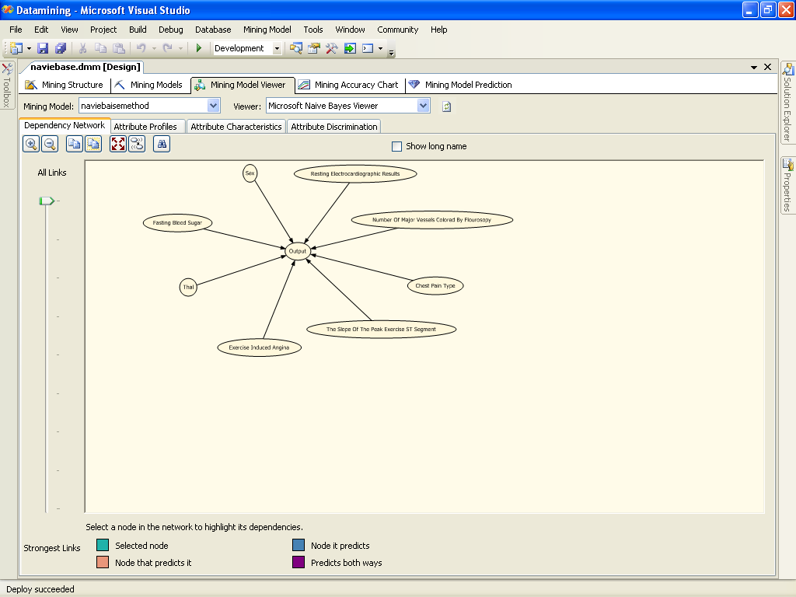

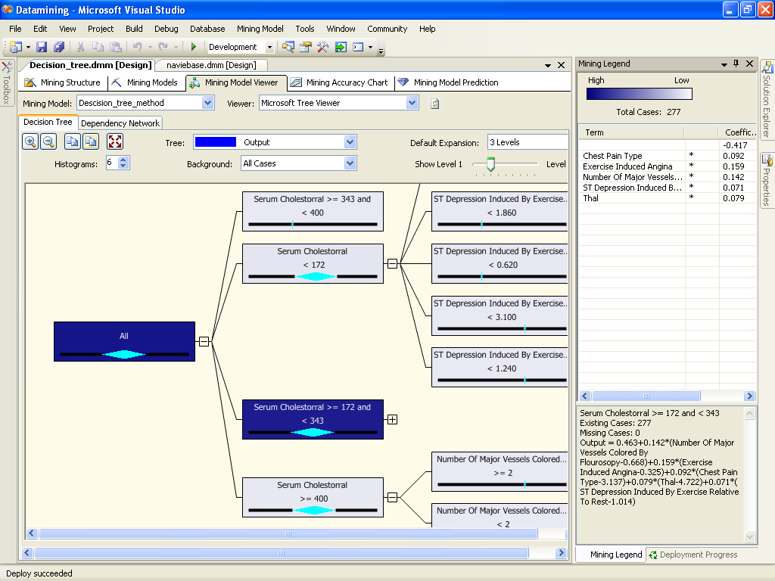

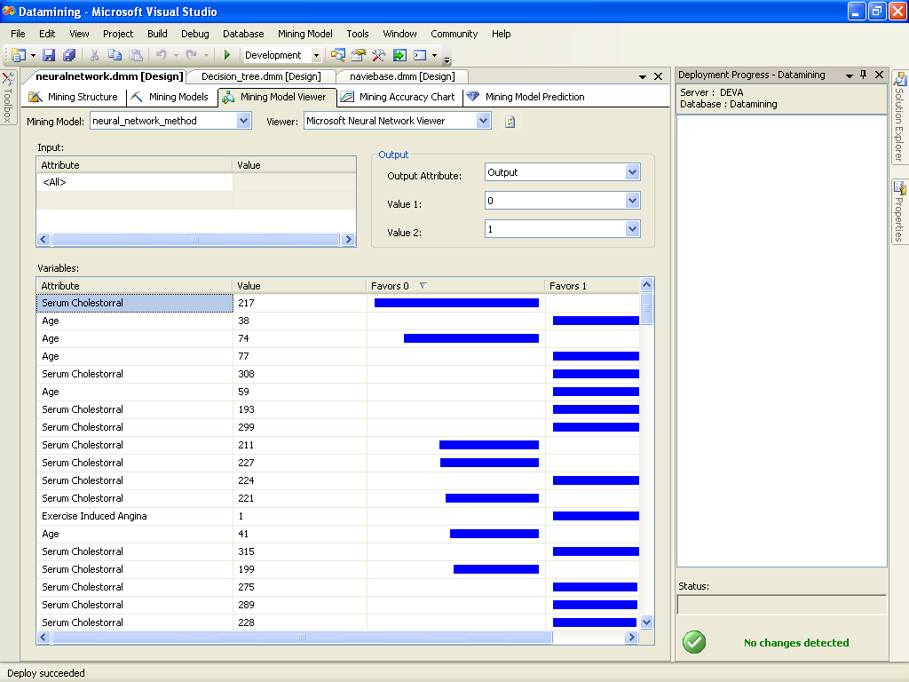

CONCLUSION

A prototype heart disease prediction system is developed using three data mining classification modeling techniques. The system extracts hidden knowledge from a historical heart disease database. DMX query language and functions are used to build and access the models. The models are trained and validated against a test dataset. Lift Chart and Classification Matrix methods are used to evaluate the effectiveness of the models. All three models are able to extract patterns in response to the predictable state. The most effective model to predict patients with heart disease appears to be Naïve Bayes followed by Neural Network and Decision Trees.

Five mining goals are defined based on business intelligence and data exploration. The goals are evaluated against the trained models. All three models could answer complex queries, each with its own strength with respect to ease of model interpretation, access to detailed information and accuracy. Naïve Bayes could answer four out of the five goals; Decision Trees, three; and Neural Network, two. Although not the most effective model, Decision Trees results are easier to read and interpret. The drill through feature to access detailed patients’ profiles is only available in Decision Trees. Naïve Bayes fared better than Decision Trees as it could identify all the significant medical predictors. The relationship between attributes produced by Neural Network is more difficult to understand. IHDPS can be further enhanced and expanded. For example, it can incorporate other medical attributes besides the 15 listed in Figure 1. It can also incorporate other data mining techniques, e.g., Time Series, Clustering and Association Rules. Continuous data can also be used instead of just categorical data. Another area is to use Text Mining to mine the vast amount of unstructured data available in healthcare databases. Another challenge would be to integrate data mining and text mining.
LIST OF REFERENCES

[1] Blake, C.L., Mertz, C.J.: “UCI Machine Learning Databases”, http://mlearn.ics.uci.edu/databases/heart-disease/, 2004.

[2] Chapman, P., Clinton, J., Kerber, R. Khabeza, T., Reinartz, T., Shearer, C., Wirth, R.: “CRISP-DM 1.0: Step by step data mining guide”, SPSS, 1-78, 2000.

[3] Charly, K.: “Data Mining for the Enterprise”, 31st Annual Hawaii Int. Conf. on System Sciences, IEEE Computer, 7, 295-304, 1998.

[4] Fayyad, U: “Data Mining and Knowledge Discovery in Databases: Implications fro scientific databases”, Proc. of the 9th Int. Conf. on Scientific and Statistical Database Management, Olympia, Washington, USA, 2-11, 1997.

[5] Giudici, P.: “Applied Data Mining: Statistical Methods for Business and Industry”, New York: John Wiley, 2003.

[6] Han, J., Kamber, M.: “Data Mining Concepts and Techniques”, Morgan Kaufmann Publishers, 2006.

[7] Ho, T. J.: “Data Mining and Data Warehousing”, Prentice Hall, 2005.

[8] Kaur, H., Wasan, S. K.: “Empirical Study on Applications of Data Mining Techniques in Healthcare”, Journal of
Computer Science 2(2), 194-200, 2006.

[9] Mehmed, K.: “Data mining: Concepts, Models, Methods and Algorithms”, New Jersey: John Wiley, 2003.

[10] Mohd, H., Mohamed, S. H. S.: “Acceptance Model of Electronic Medical Record”, Journal of Advancing Information and Management Studies. 2(1), 75-92, 2005.

[11] Microsoft Developer Network (MSDN). http://msdn2.microsoft.com/en-us/virtuallabs/aa740409.aspx, 2007.

[12] Obenshain, M.K: “Application of Data Mining Techniques to Healthcare Data”, Infection Control and Hospital
Epidemiology, 25(8), 690–695, 2004.

[13] Sellappan, P., Chua, S.L.: “Model-based Healthcare Decision Support System”, Proc. Of Int. Conf. on Information Technology in Asia CITA’05, 45-50, Kuching, Sarawak, Malaysia, 2005

[14] Tang, Z. H., MacLennan, J.: “Data Mining with SQL Server 2005”, Indianapolis: Wiley, 2005.

[15] Thuraisingham, B.: “A Primer for Understanding and Applying Data Mining”, IT Professional, 28-31, 2000.

[16] Weiguo, F., Wallace, L., Rich, S., Zhongju, Z.: “Tapping the Power of Text Mining”, Communication of the ACM. 49(9), 77-82, 2006.

[17] Wu, R., Peters, W., Morgan, M.W.: “The Next Generation Clinical Decision Support: Linking Evidence to Best Practice”, Journal Healthcare Information Management. 16(4), 50-55, 2002.

